Vectorisation of Unstructured Text Using Hadoop DFS and Spark with NLP

PROJECT DOCUMENTATION
Submitted by

Shivam Ghildiyal(15BCE0216)
Bajaj Devesh Kamal(15BCE0553)

Prepared For

Parallel and Distributed Computing (CSE4001)
– PROJECT COMPONENT

Submitted To
Prof. Manoov R

School of Computer Science and Engineering



INTRODUCTION
Vectorization of data is one of major pre processing method to be implemented on the data before giving it to the machine as all the machine learning models works on the vector space model .This preprocessing is help full to form vectors of not only Text data , as well as image matrix to vectorized and pass it to learning algorithms . Vectorization is the process of transforming words into numerical representation. It involves the accumulation of the aggregate vocabulary, mapping that vocabulary to numeric identifiers, and finally, some arithmetic involving word counts in documents, and potentially in the collection.
As the dataset given to learning algorithm is very huge so pre processing of this data set can be implemented using a distributed computing to increases the effective efficiency of the algorithm. The major advantage of the distributed computing is that , it can get more performance form the single machine and more no of resources are available for the developer to utilize and make the code and solution of problem more robust. These sorts of processing appear to the client as they are single client systems. These systems share their memory, HDD and client feel no trouble in exploring through information. There appear to be one processor with numerous PCs append to it. Client store something in his pc and the document is put away in numerous areas i.e. in joined PCs so losing of information is recovered..For the solution of the problem we are hadoop because it is scalable,effectives ,flexible,fast that any other distributed system .

OVERVIEW of Proposed System
Bag of word Model
the bag-of-words model is a simplifying representation used in natural language processing and information retrieval (IR). In this model, a text (such as a sentence or a document) is represented as the bag (multiset) of its words, disregarding grammar and even word order but keeping multiplicity. The bag-of-words model has also been used for computer vision
The bag-of-words model is commonly used in methods of document classification where the (frequency of) occurrence of each word is used as a feature for training a classifier.
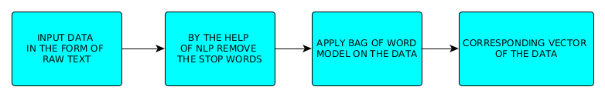

Example implementation
(1) John likes to watch movies. Mary likes movies too.
(2) John also likes to watch football games
Based on these two text documents, a list is constructed as follows:
[
"John",
"likes",
"to",
"watch",
"movies",
"Mary",
"too",
"also",
"football",
"games" ]
In practice, the Bag-of-words model is mainly used as a tool of feature generation. After transforming the text into a "bag of words", we can calculate various measures to characterize the text. The most common type of characteristics, or features calculated from the Bag-of-words model is term frequency, namely, the number of times a term appears in the text. For the example above, we can construct the following two lists to record the term frequencies of all the distinct words:
[1, 2, 1, 1, 2, 1, 1, 0, 0, 0]
[1, 1, 1, 1, 0, 0, 0, 1, 1, 1]
This vector space model is helpful for every machine leaning algorithm.
Hadoop
Hadoop runs applications using the MapReduce algorithm, where the data is processed in parallel on different CPU nodes. In short, Hadoop framework is capable enough to develop applications capable of running on clusters of computers and they could perform complete statistical analysis for a huge amounts of data.
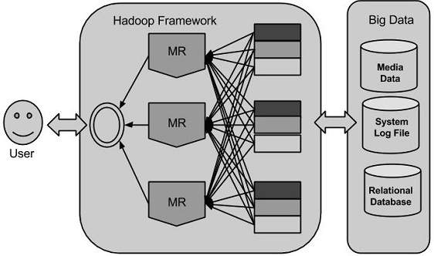
Hadoop Architecture
- Hadoop Common: These are Java libraries and utilities required by other Hadoop modules. These libraries provides filesystem and OS level abstractions and contains the necessary Java files and scripts required to start Hadoop.
- Hadoop YARN: This is a framework for job scheduling and cluster resource management.
- Hadoop Distributed File System (HDFS™): A distributed file system that provides high-throughput access to application data.
- Hadoop MapReduce: This is YARN-based system for parallel processing of large data sets.
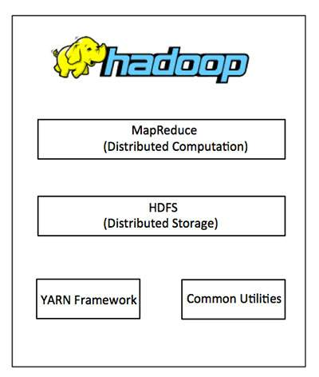

In our project HDFS and MapReduce is Using
HDFS:-
Hadoop can work directly with any mountable distributed file system such as Local FS, HFTP FS, S3 FS, and others, but the most common file system used by Hadoop is the Hadoop Distributed File System (HDFS). The Hadoop Distributed File System (HDFS) is based on the Google File System (GFS) and provides a distributed file system that is designed to run on large clusters (thousands of computers) of small computer machines in a reliable, fault-tolerant manner. HDFS uses a master/slave architecture where master consists of a single NameNode that manages the file system metadata and one or more slave DataNodes that store the actual data.
A file in an HDFS namespace is split into several blocks and those blocks are stored in a set of DataNodes. The NameNode determines the mapping of blocks to the DataNodes. The DataNodes takes care of read and write operation with the file system. They also take care of block creation, deletion and replication based on instruction given by NameNode.
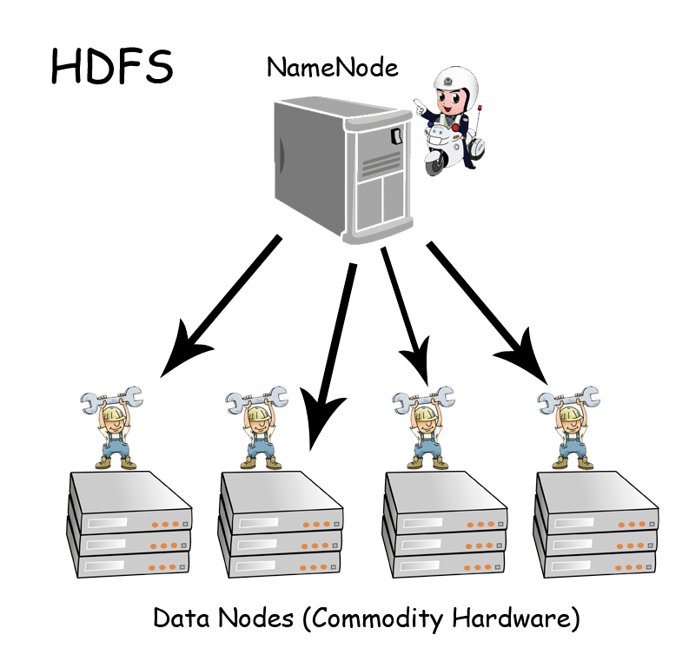

HDFS provides a shell like any other file system and a list of commands are available to interact with the file system. These shell commands will be covered in a separate chapter along with appropriate examples.
MAP Reduce –
Hadoop MapReduce is a software framework for easily writing applications which process big amounts of data in-parallel on large clusters (thousands of nodes) of commodity hardware in a reliable, fault-tolerant manner. The term MapReduce actually refers to the following two different tasks that Hadoop programs perform: The Map Task: This is the first task, which takes input data and converts it into a set of data, where individual elements are broken down into tuples (key/value pairs). The Reduce Task: This task takes the output from a map task as input and combines those data tuples into a smaller set of tuples. The reduce task is always performed after the map task. Typically both the input and the output are stored in a file-system. The framework takes care of scheduling tasks, monitoring them and re-executes the failed tasks. The MapReduce framework consists of a single master JobTracker and one slave TaskTracker per cluster-node. The master is responsible for resource management, tracking resource consumption/availability and scheduling the jobs component tasks on the slaves, monitoring them and re-executing the failed tasks. The slaves TaskTracker execute the tasks as directed by the master and provide task-status information to the master periodically. The JobTracker is a single point of failure for the Hadoop MapReduce service which means if JobTracker goes down, all running jobs are halted.
Spark :-
Apache Spark is a lightning-fast cluster computing technology, designed for fast computation. It is based on Hadoop MapReduce and it extends the MapReduce model to efficiently use it for more types of computations, which includes interactive queries and stream processing. The main feature of Spark is its in-memory cluster computing that increases the processing speed of an application
Spark is designed to cover a wide range of workloads such as batch applications, iterative algorithms, interactive queries and streaming. Apart from supporting all these workload in a respective system, it reduces the management burden of maintaining separate tools.

Features of Apache Spark
- Speed
- Support Multiple Languages
- Advance Analatics

Spark Built on Hadoop
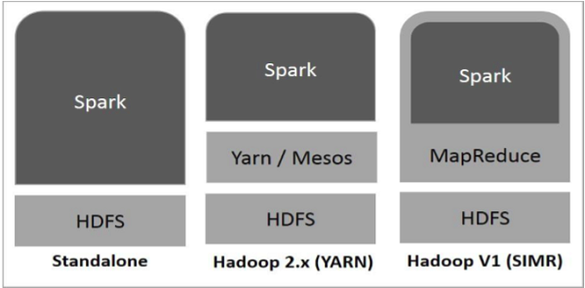

`Components of Spark
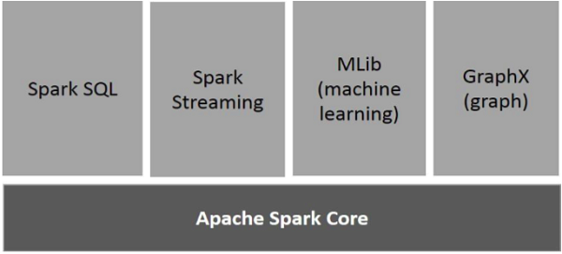

Hadoop Multi node
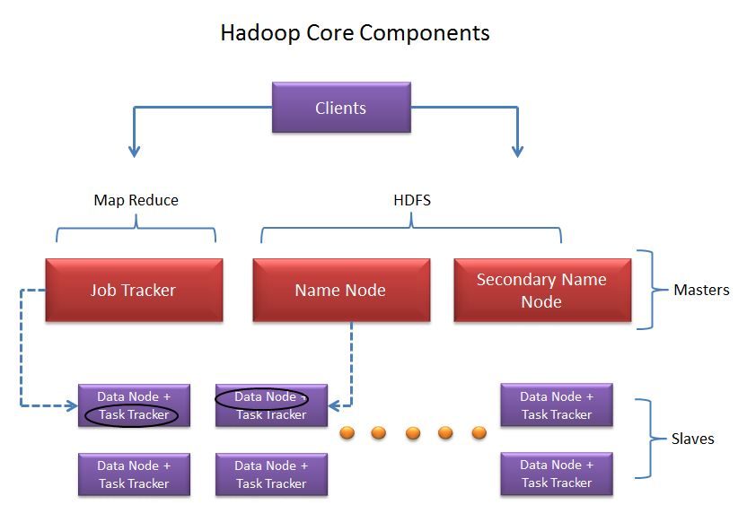
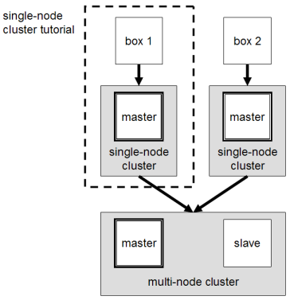

Data Flow Diagram of Proposed System

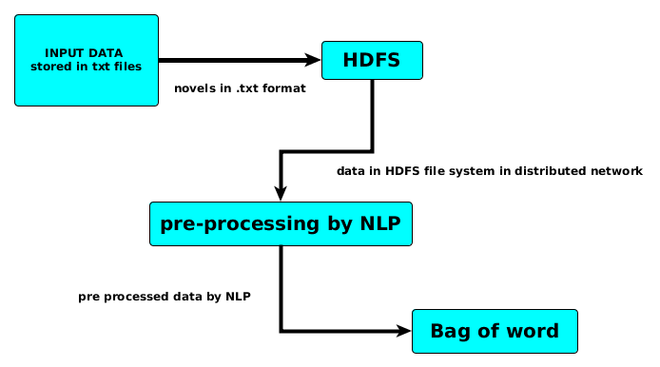
Results and implementation
CODE and Datasets are available on the GIT
https://github.com/deveshbajaj/Parallel_distributed
screen shots available on the git repository
(Folder name screenshots)

